Methodological investigation

Jiarui Qi

Word count: 1231

Introduction:

In the human development process, coastal areas are always important pivots of a country’s economy and densely populated areas, which are extremely vulnerable to natural disasters. In the past, people weren’t able to cope with coastal hazards but to escape. But as economy and technology improved, it is more and more important to manage the disasters properly in order to reduce their threats to the safety of life and property of coastal residents. Nowadays, scientists can collect data from former disasters and use data science methods to compare, observe, and correlate them, finding patterns of these hazards and finally introducing ways to deal with them. I will talk about 2 data science methods scientists used to turn the complicated disaster problems into simple ones.

1. Mohanty, P.C., Panditrao, S., Mahendra, R.S. et al. Geospatial Assessment of Flood Hazard Along the Tamil Nadu Coast. J Indian Soc Remote Sens 47, 1657–1669 (2019). <https://doi.org/10.1007/s12524-019-01012-7>

In this article, the authors mainly focused on the effect of floods and extreme rainfall on the densely populated Tamil Nadu Coast in southeast India. The researchers first divide the the coast area under threat of hazards into two separate parts: the flooding area, in which the level of hazards may be higher, and the built-up area, in which the damage to human lives and economic losses may be more severe. Then the authors analyzed data in these two part using different methods and combine them at last, obtaining a comprehensive result with distinct characteristics in both aspects. As shown in the graph below, scientists used the Sentinel-1 SAR method to study the flooding area and the Landsat-8, OLI method to study the built-up area inundation.

When it comes to the Sentinel-1SAR method, it includes 4 steps to process data. In the first step, scientists used VV polarization mode (vertical launch and vertical receive of electromagnetic wave ) and IW (Interferometric Wide swath) to extract ground range detected (GRD) data in flooding area of the study region. In short, high resolution special geospatial image was formed. After that, the image experience a series of corrections like radiometric calibrations (corrections to the radar back-scatter), Lee filer (quality improvements in the texture of the image), and Range Doppler Terrain Correction (corrections on the distortions of the distance in the image due to topographical variations of a scene and tilt of satellite sensor). Finally, the histogram analysis and binary image of the flooding area was carried out.

The Landsat-8 OLI processed the Built-up area extraction by firstly using EarthExplorer to acquire imagery contains no cloud cover and atmospheric correction. Then, 4 equations are used to process the ToA (Top-of-Atomsphere) information.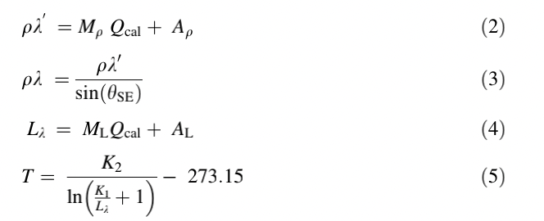Top-of-Atmosphere ToA planetary reflectance values was developed using Eqs. 2 and 3. ToA radiance conversion was done using Eq.4 which subsequently converted into at sensor brightness temperature in degree Celsius using Eq. 5.

After accuracy assessment using BAEM (built-up area extraction method), a GIS analysis was carried out and the level of risk of disasters came out. After combining the two main Methods and their results, a comprehensive flood map was developed to assess flood risk in two ways: population and and building density and seriousness of the floods.

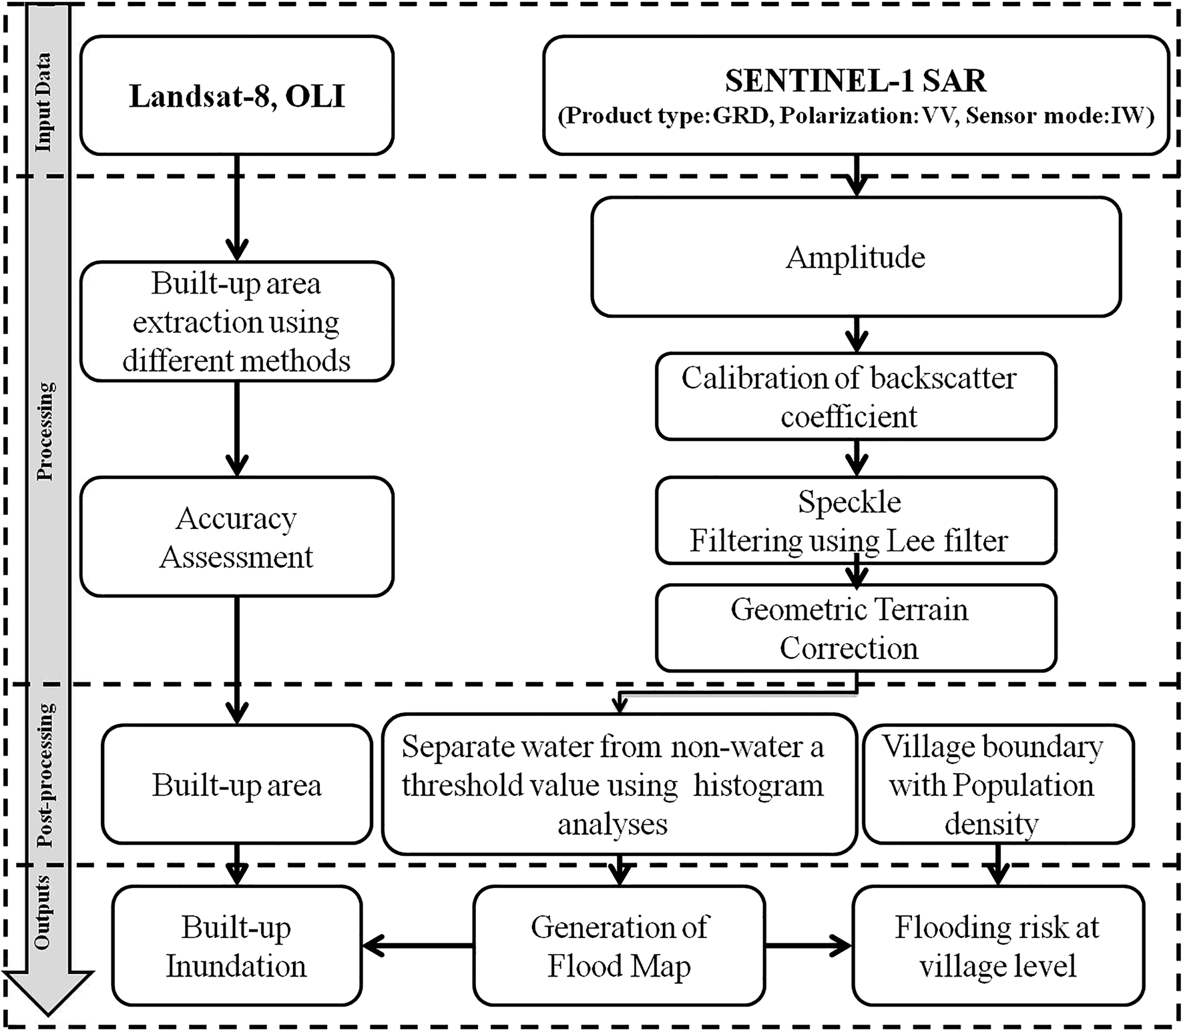

The method used in this passage assessed the risk of hazards like floods and extreme rainfall in Tamil Nadu Coast in southeastern India. Being aware of the risks and characteristics of the hazards, scientists can make reasonable predictions and preparations of them, reducing the economic losses and promoting human development.

2.Muhammad Al-Amin Hoque, Naser Ahmed, Biswajeet Pradhan, Sanjoy Roy,

Assessment of coastal vulnerability to multi-hazardous events using geospatial techniques along the eastern coast of Bangladesh,

Ocean & Coastal Management,

Volume 181,

2019,

104898,

ISSN 0964-5691,

<https://doi.org/10.1016/j.ocecoaman.2019.104898.>

(https://www.sciencedirect.com/science/article/pii/S0964569119301486)

In this article, the author discussed the coastal vulnerability to natural disasters and the study area moved to the eastern coast of Bangladesh. To access vulnerability, scientists mainly used CVI (coastal vulnerability index) approach. In order to develop an integrated CVI map, the author first selected 8 parameters: Elevation, Sea level rise, Slope, Mean tide range, Geomorphology, Bathymetry, Shoreline change and Storm surge height. To process Geomorphology, scientists used the geospatial data science method of Landsat 8 OLI and visual interpretation. To process Elevation and Coastal slope, scientists used Digital Elevation Model (DEM) at 10m spatial resolution; To process the Shoreline change rate, scientists also used Landsat OLI, MSS, and TM. To process Sea level change and Mean tide range, scientists used daily tide gauge. For the Bathmetry, scientists used Topo sheet and observed Historical cyclone to process the storm surge height. After gathering these information, scientists analyzed the vulnerability classes of each parameter and rank them based on their vulnerability. To directly show the vulnerability of each parameter, scientists divided the 470-kilometer-coast in 470 1km \* 1km grids. After that, 8 parameters are studied to find out how many grids with high vulnerabilities on the coast do each parameter have. Results turned out that about 152km of the coastline is located in a highly vulnerable zone according to the parameter of Elevation, which is level 4 and 5 (high and very high rate). For the Coastal slope, it is 334km. For the Geomorphology, it is 282km. For the Storm surge height, it is 194km. For the Bathymetry, it is 92 km. For the Shoreline change , it is 176km. For the Sea level rise, it is the entire coastline. For the Tide range, it is about 93km. Finally, the CVI can be calculated as the square root of the ranked parameters divided by the total number of parameters using this equation:

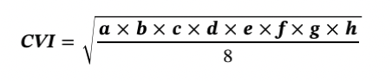

According to the equation, about 122km of coastline is categorized into high to very high vulnerability to coastal hazards. Besides doing calculations, scientists also visited 22 locations and verify the CVI results and the results of observation is similar to the calculation, which proved the validation of the CVI results.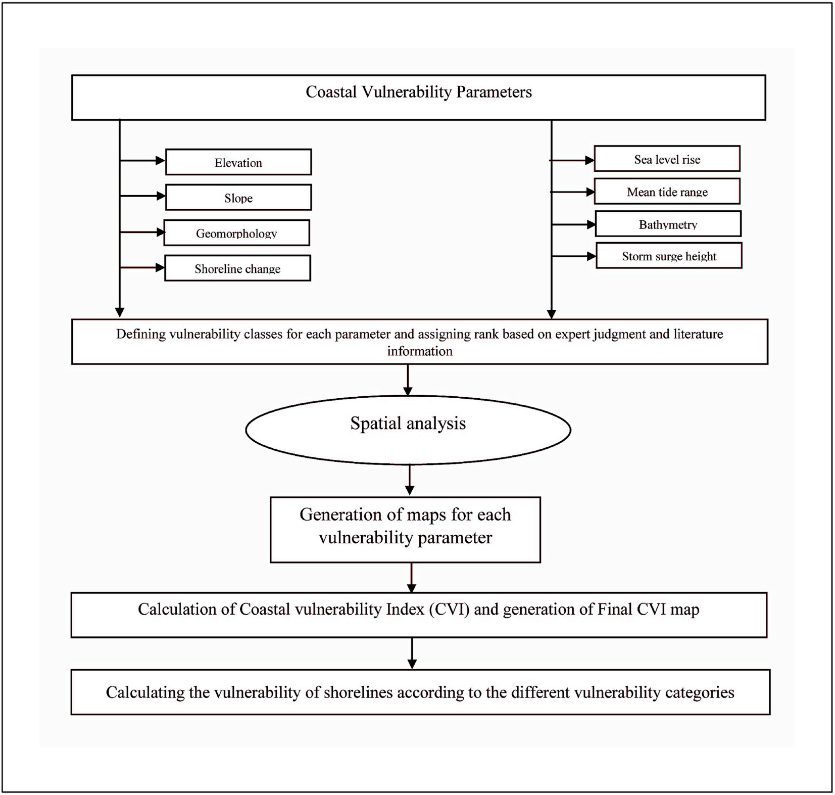

Based on the current CVI results, scientists can pay attention to the high level vulnerability areas and save the time and money used on monitoring low vulnerability areas. Also, the result can also be utilized by the government to manage natural disaster like predictions and post-disaster reconstructions, lowering the impacts of hazards.

Conclusion:

Each of the two data science geospatial methods divided the complicated disaster management problems into some independent factors, which is much less difficult than solving the problem as a whole. After detailed analysis of those factors, scientists combined these results to form a whole picture of the disaster managements on coastal areas. What’s more, both methods I introduced used some efficient geospatial methods like Landsat OLI. Also, the first passage aimed at finding potential risks and finally developed a hazard risk map. And the second passage found out highly vulnerable coastal areas as well. When it comes to the differences, in the first passage, scientists focused more on the areas in which disasters can bring serious effects to human. In the second passage, however, the authors paid attention to places where the hazards are likely to take place in, which focused more on the natural disaster itself. I think if scientists can combine those two ways together, the study would be more comprehensive. Apart from this tiny limitation, the two passages both showed good skills on processing data, comparing, and combining them to be aware of the coastal situation in details. Based on these methods, scientists can make proper and precise predictions using information detected on the hazard risk maps and CVI maps. For the policymakers, they can formulate new policies that are suitable to the method to maximize human developments by providing economic losses and other losses brought by natural disasters, making coastal areas a better and safer place for country developments.